**BAF504 투자분석 HW4**

20249433 최재필

**(a)**

- MSFT (Microsoft)

- GOOG (Google)

- KO (Coca Cola)

- SPY (S&P500) – BM

- IRX (3-month T-bill) – Risk-free

Data period: 2019-08~2024-05

Source: Yahoo Finance

**(b)**

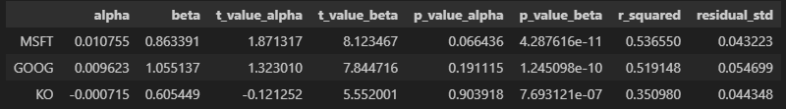

**(c)**

I tried to do this:

* Imagine you have a time machine. You travel back 2 years.
* Given that our data spans from 2019-08 ~ 2024-05, you’re going back to 2022-06.
* Now you have “past” 3-year data and “future” 2-year data.
* Because you “know” the future, you can accurately estimate “future” values of market risk premium, standard deviation and the alphas of the expected return
  + You can run CAPM regression on future 2 years (24 months) to get alpha estimate.
  + You can also calculate mean return and standard deviation of market excess return on future 2 years.
* You estimate other values using “past” data
  + You can run CAPM regression on past 3 years to get beta estimate

However, because weights are too extreme, typical weight normalization didn’t work. Weight normalization using absolute sum was used.

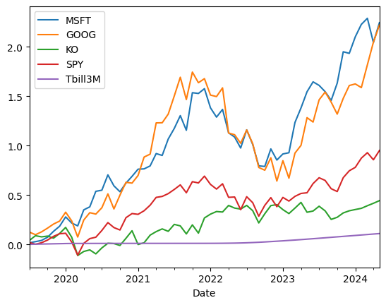

Estimated alphas from “future” 2 years:

|  |  |  |  |  |
| --- | --- | --- | --- | --- |
|  | MSFT | GOOG | KO | SPY |
| alpha (ann.) | 9.54% | 13.36% | 7.79% | - |

Estimated risk premium of SPY from “future” 2 years:

11.09%

The results were:

|  |  |  |  |  |
| --- | --- | --- | --- | --- |
|  | MSFT | GOOG | KO | SPY |
| weight | 0.107 | 0.134 | -0.546 | 0.211 |

But because weights were normalized with absolute sum, now the sum of weights is not 1.

**(e)**

Information Ratio is:

5.92% / 0.0649 = 0.911

**(f)**

Note that Sharpe is calculated using only “future” 2 years. (2022-06~2024-05)

|  |  |  |
| --- | --- | --- |
|  | Index | Optimal |
| Sharpe | 0.57 | 1.08 |